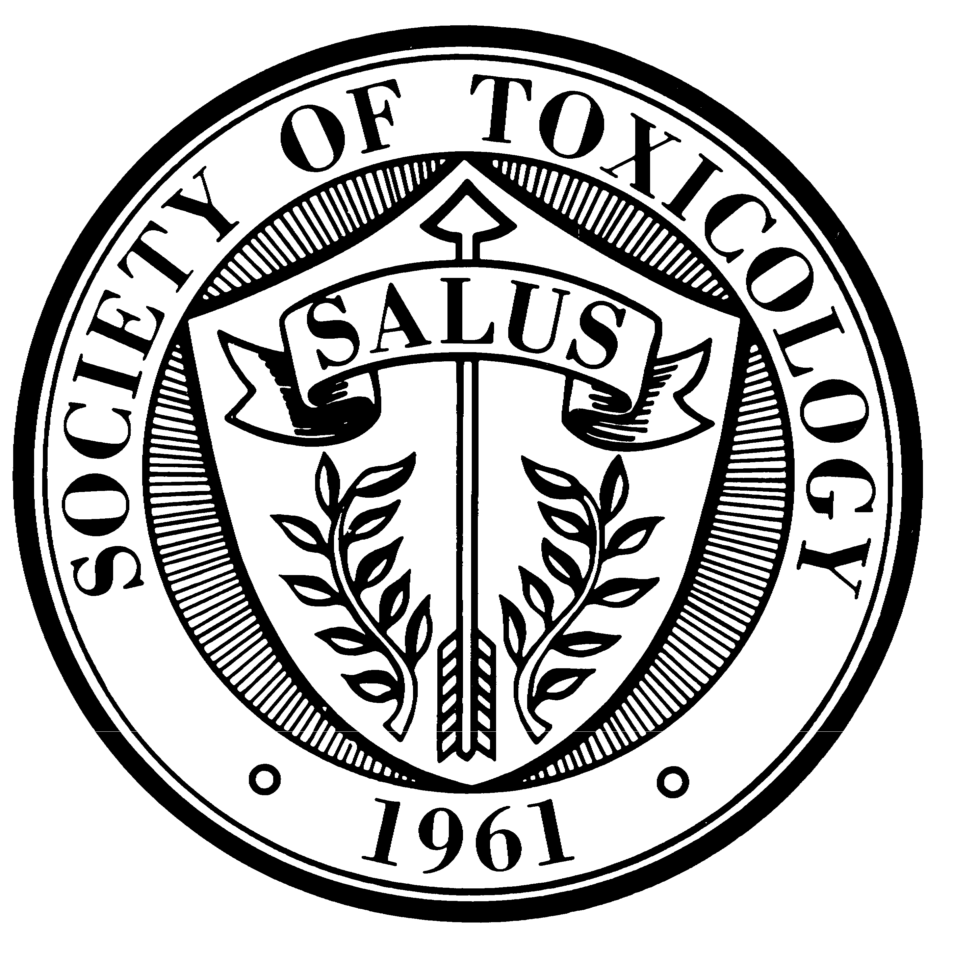

BACKGROUNDER:
Air Pollution and Childhood Asthma

The problem of childhood asthma is serious—and growing. It is a major public health problem of increasing concern in the United States.

Asthma occurs in about five million American children, according to the University of Maryland Medical Center. Each year about 200,000 of them are hospitalized. It is the most common chronic childhood illness. About half of all cases of asthma develop before the age of ten, and about 38 percent of patients develop symptoms before they are five years old. Unfortunately, there are currently no preventive measures or cure for asthma.

For unexplained reasons, there has been an alarming increase in the rate of asthma among children. The percentage of children with asthma has increased over the past two decades, from three percent in 1981 to six percent in 2002, where it remained through 2004 (Child Trends Databank. Low-income populations, minorities and children living in inner cities experience disproportionately higher morbidity and mortality due to asthma.

One reason for this increase may be particulate chemicals in the environment, but a link between the two hasn’t been scientifically established. However, there is a concern about the long-term consequences of widespread exposure to ozone in children.

The possible connection between oxidant air pollution and childhood asthma is the topic of a symposium that will take place at the 47th “Annual Meeting of the Society of Toxicology on Monday, March 17, from 1:30 – 4:30 p.m. in Seattle, WA. The co-chairs of the session are Laura Van Winkle, University of California Davis, Davis, CA, and Jack Harkema, Michigan State University, East Lansing, MI

“Ozone is one of the primary constituents of smog,” says Van Winkle. “Under the Clean Air Act, the U.S. EPA has set protective health-based standards for ozone. However, in 2005, 98 million people lived in U.S. counties with ozone concentrations above the eight hour National Ambient Air Quality Standard of 0.08.

“There continues to be concern about the long term sequelae of widespread ozone exposures in sensitive populations, particularly children. This concern has been heightened by a recent surge in asthma prevalence in children, with disproportionately higher morbidity and mortality due to asthma for inner city children.”

“The lung continues to grow and differentiate into adulthood,” adds Harkema. “Interaction with air pollutants such as ozone during post-natal development of the respiratory system may alter the normal pattern of either growth or differentiation in such a way as to predispose to disease. Recent research has been defined by several important features regarding ozone exposure in children, including critical windows of susceptibility to ozone for both the structural and immune components of the respiratory tract, genetic markers for increased risk for decrements in lung function due to ozone exposure, and interaction effects with allergic sensitization and pre-existing inflammation.”

The purpose of this session is to bring together the most current basic and applied research on the influence of ozone on the development of the lung. In addition to Dr. Van Winkle, the presenters include Talat Islam, University of Southern California, Los Angeles, CA, and Steven Kleeberger, NIEHS, Research Triangle Park, NC.

# # #

BACKGROUNDER:
Environmental Influence on Female Puberty and Breast Tumorigenesis

For a number of years, the media (Women’s Enews, March 30, 2007) have been concerned about the onset of puberty in girls, and environmentalists have indicated that changes in the environment may affect female hormones related to puberty and breast cancer. Some scientists think that agents in the environment, such as endocrine disrupting chemicals or other dietary factors, may mimic estrogen. This results in rapid development of the mammary gland, putting the gland at higher risk for cancer.

Is there a connection between the environment, early female puberty and breast cancer? Scientific reports suggest an association among the environment, early female puberty, and breast cancer.

“Breast cancer is a complex disease, resulting from both genetic and environmental influences,” says Elizabeth Maull of the National Institute of Environmental Health Sciences in Research Triangle Park, N.C. “Environmental exposures during critical windows of mammary gland development may be responsible for altering tissue susceptibility resulting in increased risk of future breast cancer. The pubertal hypothesis suggests that external agents, such as endocrine disrupting chemicals or other dietary factors, may mimic estrogen or influence their levels, such that the period of rapid development of the mammary gland is extended, putting the gland at higher risk for a transition to carcinogenesis.”

Dr. Maull is chairing a symposium, “Environmental Influence on Female Puberty and Breast Tumorigenesis,” at the 47th Annual Meeting of the Society of Toxicology in Seattle on Monday, March 17, from 1:30 – 4:15 p.m. The co-chair of the session is Coral Lamartiniere of the University of Alabama at Birmingham (Ala.).

“The aim of this session is to present the latest findings relating early environmental exposures with alterations in pubertal milestones that predispose breast cancer,” says Dr. Lamartiniere.

Among the topics that will be addressed:

- Environmental Influence on Female Puberty and Breast Tumorigenesis – Dr. Maull
- The Effect of Environmental Exposures on Mammary Stem Cells During Puberty—Mary Helen Barcellos-Hoff, Lawrence Berkeley National Laboratory, Berkeley, Calif.
- Prenatal Exposure to Bisphenol A (BPA) Induces Genomic Alterations in the Rat Mammary Gland—Jose Russo, Fox Chase Cancer Center, Philadelphia, Penn.
- Neonatal/Prepubertal Bisphenol A Exposure Alters the Mammary Proteome and Increases Susceptibility for Chemically-Induced Mammary Cancer in Rats. Coral Lamartiniere, University of Alabama at Birmingham, Birmingham, AL
- The Environmental Impact of Diet and Obesity on Breast Carcinogenesis—Deborah Clegg, University of Cincinnati, Cincinnati, Oh.
- The Breast Cancer and the Environmental Research Centers: A Novel Transdisciplineary Approach to Understanding the Causes and Mechanisms of Breast Canter—Deborah Winn, National Cancer Institute, Bethesda, Md.

# # #

BACKGROUNDER:
Over-the-Counter Cough and Cold Medications in Children: Efficacy, Safety and Use

Parents in the U.S. spend around $500 million annually to purchase 95 million boxes containing almost four billion doses of over-the-counter (OTC) pediatric cough and cold products, despite the absence of any published evidence that they are effective.

The U.S. Food and Drug Administration in October 2007 recommended that these drugs not be used to treat infants and children under two years of age because “serious and potentially life-threatening effects can occur.”

Both the American Academy of Pediatrics and the American College of Chest Physicians have published statements on the lack of efficacy of OTC cough and cold products in children. Nevertheless, many parents—including those trained as biomedical scientists—believe that these OTC products provide beneficial effects in their children.

Decongestants have been linked to cardiac arrhythmias and hypertension, antihistamines with sedation and visual hallucinations, and antitussives with depressed levels of consciousness and encephalopathy (brain disease), particularly in children under the age of six.

The efficacy, safety and use of OTC cough and cold medications will be the topic of discussion at a special roundtable when the Society of Toxicology conducts its 47th Annual Meeting in Seattle on Tuesday, March 18, from 7:30 to 8:50 a.m. The session is chaired by Charles Vincent Smith of Seattle Children’s Hospital Research Institute and Sid Nelson of the University of Washington in Seattle.

“An FDA review over past decades identified 123 deaths associated with the use of OTC cough and cold products in children less than six years of age, over the past several decades associated with use of OTC cough and cold products,” Dr. Smith says. “This number has been questioned due to inclusion of examples in which other factors may have been dominant and, conversely, the identification of true cases may be incomplete.

“Whatever the true measure, the number of deaths has been interpreted either as small, relative to the millions of children dosed, or as unjustifiable, in absence of evidence of efficacy. Additional concerns are that virtually nothing is known of potentially adverse effects of these products on child development.”

The advisory panel convened by the FDA in October 2007 produced a vigorous discussion of the need for better data on risks and benefits in children of OTC cough and cold medications. In addition to the direct importance of the topic, this controversy serves as an example of several core issues relevant to toxicologists, regulatory personnel and consumers.

“One issue is that children are not simply small adults,” adds Dr. Nelson, “and differences from adults in physiologies and susceptibilities to pharmacological and environmental exposures need to be considered and studied so that rational judgments and risk/benefit assessments can be made.

“A second consideration arises from the broader question of how best to use incomplete data for evidence-based risk/benefit evaluations and decision-making processes that can be applied in timely and useful policies. Discussion of these principles will enhance our efforts to identify the most important questions to be addressed by ongoing and future research.”

Also participating in the Special Roundtable are:

- Wayne Snodgrass of the University of Texas Medical Branch at Galveston in Galveston, Tex.;
- Philip D. Walson from the University of Cincinnati in Cincinnati, Oh.; and
- Richard C. Dart of the Rocky Mountain Poison and Drug Center at Denver Health in Denver, Col.

# # #

BACKGROUNDER:
Human Health Risk Assessment for Pharmaceuticals in the Environment

Numerous studies have documented the presence of low levels of mixtures of emerging contaminants, including human and veterinary medicines, in surface water. These findings are gaining increasing attention.

Contaminants in surface water include prescription drugs such as hormones, antidepressants and antibiotics; over-the-counter medicines such as pain relievers, cold/flu remedies and antiseptics; and veterinary medicines. Small concentrations of these substances are found in various waterways nationwide. Further research suggests that certain drugs may cause ecological harm. To date, scientists have found no evidence of adverse human health effects from pharmaceuticals in the environment.

However, others point out that the continual input of pharmaceuticals into a body of water can cause the concentration to be relatively constant. And while they may not kill aquatic organisms, medications may interfere with growth and reproduction in water organisms by disrupting their endocrine system, particularly when exposure occurs during developmentally sensitive times such as before birth. There are several well-documented effects on fish and wildlife.

The possible risk of pharmaceuticals in the environment (PIE) is the subject of a Roundtable Session at the Annual Meeting of the Society of Toxicology on Tuesday, March 18, from 1:30 – 4:15 p.m. The session is chaired by Daniel Caldwell of Johnson & Johnson in New Brunswick, NJ, and Hal Zenick from the U.S. EPA in Research Triangle Park, NC.

“Scientists and the media are questioning the potential impact of these substances on human health and on environmental species,” says Caldwell. “Several issues need to be considered. For example, what are the pathways of entry of human and veterinary medicines to the environment and how can potential exposures be derived from monitoring and modeling data? “

“Significant water reuse in certain regions of the U.S. and the current state of water treatment underscore the importance of valid exposure assessments related to pharmaceuticals in the environment,” adds Zenick. “Pre-clinical and clinical toxicology, pharmacology and metabolic data generated during the process of drug development and registration can be used to support human health risk assessments.”

The Federal Interagency PIE Working Group has been formed to identify some of the key definitional issues, data gaps, research priorities and collaborations. In addition, there are U.S. EPA mandates and regulations that could be applied and critical considerations need to be defined. This session addresses these issues and provides an interactive discussion among attendees and speakers.

# # #

BACKGROUNDER:
Toxic Pet Food and Nephropathy in Dogs and Cats

How safe is your pet’s food? Last year, pet owners had some cause for concern. In March 2007, Menu Foods, whose products are sold throughout North America, issued a recall for 60 million cans and pouches of dog and cat food products because affected food may have contributed to kidney failure in dogs and cats. This led to a condition called nephropathy, which refers to damage to or disease of the kidney.

According to NewScientist.com (Nov. 28, 2007), a lethal combination of melamine and cyanuric acid was to blame, although neither chemical had a history of toxicity. Melamine is an organic base for plastics and resins, and cyanuric acid is used in swimming pools. Both were illegally added in China to wheat and rice gluten to raise nitrogen levels. The combined ingredients were subsequently exported to the U.S. and added to pet food by manufacturers.

Melamine was put in pet foods in order to artificially increase protein levels,” says Jim Riviere of North Carolina State University. “Melamine and cyanuric acid are additives that adulterated the pet food supply.”

Dr. Riviere is chairing a roundtable session on “The 2007 Pet Food Related Toxic Nephropathy in Dogs and Cats” at the 47th Annual Meeting of the Society of Toxicology in Seattle on Tuesday, March 18 from 7:30 – 8:50 a.m. The co-chair of the session is Ramesh Gupta of Murray State University in Hopkinsville, KY.

“We realized that this might be a case of toxicology that was developing in front of our eyes,” adds Riviere, “so we decided to present it to the Society of Toxicology.” The roundtable session will present the latest findings into the investigation of toxic pet food. The presenters include:

- Sharon Gwaltney-Brant of the Animal Poison Control Center in Urbana, IL.
- Karyn Bischoff of Cornell University in Ithaca, NY;
- Wanda Haschek-Hock of the University of Illinois in Urbana, IL; and
- Stephen Sundlof of the U.S. Food and Drug Administration in Rockville, MD.

“The focus of this session will be to provide an up-to-date overview of the pet food related toxic nephropathy that swept across the United States and Canada in 2007,” according to Dr. Gupta. “This episode was unique in both the breadth and rapidity of its occurrence as well as to the unique nature of its toxicological manifestations. It exposed the public to a large-scale toxicological investigation in progress, and has had significant impact on assessing safety of imported foods for both animal and human consumption.

“The epidemiology, clinical manifestations, pathology and potential mechanisms of action,” Gupta adds, “as well as the regulatory response and management of the crisis will be reviewed as it relates to this issue.”

# # #

BACKGROUNDER:
Future Paths for Puget Sound

The future of one of the most ecologically diverse and environmentally sensitive areas of Washington State will be discussed at the 47th Annual Meeting of the Society of Toxicology on Monday, March 17, from 1:30 – 4:15 p.m. at the Washington State Trade and Convention Center in Seattle.

A panel of outstanding experts from Seattle, Olympia and LaConner, WA, as well as Triangle Park, N.C. and Boston, MA, will discuss “Future Paths for Puget Sound: Contaminants, Cultures and Ecosystem Risk Characterization.”

The Puget Sound Georgia Basin ecosystem is one of the most ecologically diverse in North America. It extends from the Campbell River in Northern British Columbia, Canada, to the Nisqually River in Central Western Washington in the U.S

The health of this ecosystem is a cornerstone of the region’s quality of life and vibrant economy. The current population in this region is over 6 million people with projections of more than 10 million by 2020.

The area is ethnically diverse with increasing representation of Asian, Latin and European cultures. The area is also home to many First Nation communities (Canada) and Tribal Nations (U.S. side) with long established cultural, social, religion and resource-based traditions and customs within these local areas.

However, this uniquely valuable region faces increasing pressures and the vital relationship between ecosystem health, human health and ocean are at risk. Of particular challenge to the scientific community is the complexity and interrelatedness of these pressures for predicting and protecting human and ecosystem health. This session will explore these relationships.

Case examples from the region will describe ecosystem challenges in relationship to persistent organic pollutants and marine mammal health populations. The regional public health risk assessment dilemmas for encouraging consumption of “heart and brain healthy” seafoods will be discussed in relationship with risk messages warning of eating contaminated seafoods that may contain neurodevelopmentally toxic or cancer causing substances.

The importance of understanding the dynamics of naturally produced toxins such as those from harmful algal blooms, the significance of microbial contaminants, such as vibrio, and the presence of persistent environmental pollutants that bioaccumlate, will illustrate the need for integrated public health relevant risk assessments and prevention measures for this region.

Presenters include:

- Puget Sound Partnership, Annie Jarbek, NIEHS, Research Triangle, NC
- State of the Puget Sound, William Ruckelshaus, Salmon Recovery Funding Board, Seattle, WA
- Oceans and Human Health: Lessons Learned from the Puget Sound, Elaine Faustman, Institute for Risk Analysis and Risk Communication, Seattle, WA
- Marine Ecosystems and Human Health in Puget Sound, Usha Varansi, NOAA Fisheries, Northwest Fisheries Science Center, Seattle, WA
- Mercury Exposure in a Group of Puget Sound Area Asian-American Women of Child-Bearing Age, Koenraad Marien, Office of Environmental Health Assessments, Olympia, WA
- Defining Cultural Well-Being for Tribal Nations: Going Beyond Acceptable Levels of Risk, Jamie Donatuto, Swinomish Indian Tribal Community, LaConner, WA
- Balancing the Health Benefits and Risks of Seafood Consumption, David Bellinger, Harvard Medical School, Boston, MA

# # #

